**Chapter 6 note:**

Outline:

* The Price Elasticity of Demand and Its Measurement
* The Determinants of the Price Elasticity of Demand
* The Relationship between the Price Elasticity of Demand and Total Revenue

Price Elasticity of Demand

* Elasticity: *Percentage change in one variable resulting from a 1-percent increase in another.*
* Price Elasticity of Demand: *Percentage change in quantity demanded of a good resulting from a 1-percent increase in its price.*
* Text, whiteboard

  Description automatically generated
* Chart, line chart

  Description automatically generated
* Chart, line chart

  Description automatically generated

Calculating Elasticity at a Point

* + If we have the demand function, we can calculate elasticity at a given point.
    - 
  + ΔQ/ΔP = - .2
    - But that’s not elasticity.
    - We need to have P and Q, as well.
  + Suppose that P=85, I = 300, and PY = 50 then Q = 48
  + So, elasticity, at that point, was
    - Ep= (-.2) (85/48) = -.35
  + If we have only two observations from a demand schedule, then we must calculate elasticity over that range.
  + Percentage change will be different if you move from a point A on the demand curve to point B, or from point B to A.
  + To avoid that problem, we use the midpoint formula for percentage changes.
    - * *percentage change = (A-B) / [(A+B)/2]*

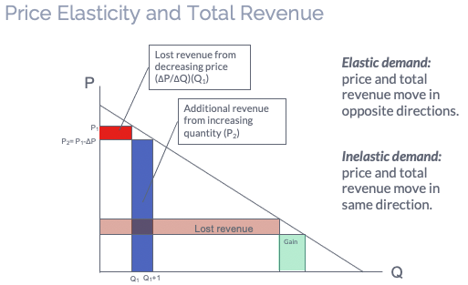

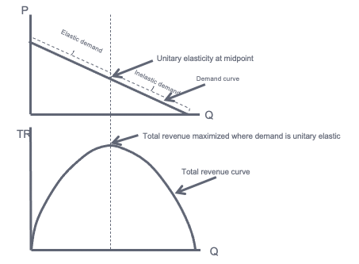

Estimating Price Elasticity of Demand

* We can see that knowing the price elasticity of demand would be very useful for a firm. But how can a firm know this information?
* For a well-established product, economists can use historical data to estimate the demand curve.
* To calculate the price elasticity of demand for a new product, firms often rely on market experiments.

Answer:

Breakfast cereal has close substitutes, so buyers can easily switch if the price rises.

Sunscreen has no close substitutes, so consumers would probably not buy much less if its price rises.

Lesson: ***Price elasticity is higher when close substitutes are available.***

Answer:

For a narrowly defined good such as blue jeans, there are many substitutes.

There are fewer substitutes available for broadly defined goods.

Lesson: ***Price elasticity is higher for narrowly defined goods than broadly defined ones.***

Answer:

To millions of diabetics, insulin is a necessity. A rise in its price would cause little or no decrease in demand.

A cruise is a luxury. If the price rises, some people will forego it.

Lesson: ***Price elasticity is higher for luxuries than for necessities.***

Answer:

There’s not much people can do in the short run, other than ride the bus or carpool.

In the long run, people can buy smaller cars or live closer to where they work.

Lesson: ***Price elasticity is higher in the long run than the short run.***



**Determinants of Income Elasticity**

Income elasticities also differ from the short run to the long run.

* For most goods and services—foods, beverages, fuel, entertainment, etc.— the income elasticity of demand is larger in the long run than in the short run.
* For a durable good, the opposite is true. The short-run income elasticity of demand will be much larger than the long-run elasticity.



